SAMPLE GRAPHS
Drag vs Velocity
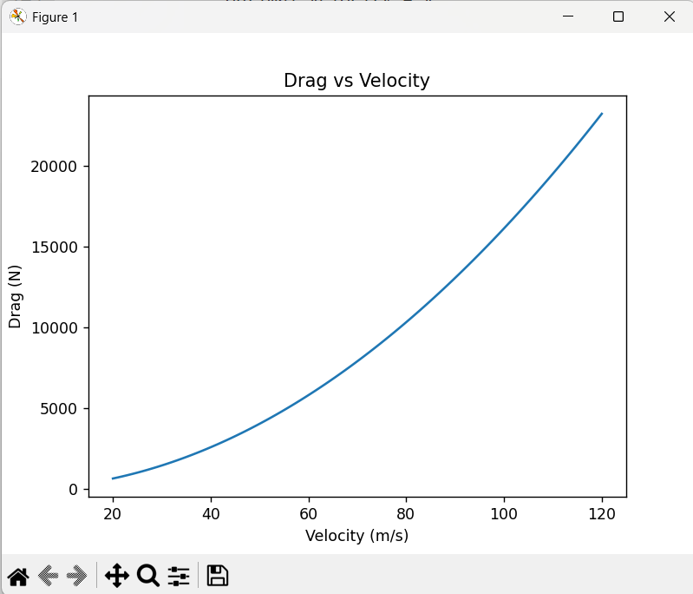

Range vs Velocity
